User mode

>

Login to privilege mode

> enable

#

Switch to Global Configuration mode

# config terminal / config t / config

(config)#

Exit from mode

(config)# exit

# exit

>

To see or complete commands use ?

> ?

Show current configuration

# show run | #sh run

**1. Program to configure a CISCO switch with basic configuration**

---------------------------------------------------------------

Switch 3560

Set Hostname to the Switch

(config)# hostname Switch1

Switch1(config)#

Set Password for user mode

(config)# enable password level 1 12345

Set password for privilege mode

(config)# enable secret 123456

------------------------------------------------------------------

**2. Program to configure a CISCO Router with basic configurations**

------------------------------------------------------------------

Set Hostname to the Router

Router(config)# hostname Router1

Router1(config)#

Set User mode password

Router(config)# line console 0

Router(config-line)# password 1234

Router(config-line)# login

Set Privilege mode password

Router(config)# enable secret 1234

-------------------------------------------------------------------

**3. Program to simulate remote login and configure a Switch in a network**

-------------------------------------------------------------------

(config)# enable secret 123

To set console login password

(config)# line console 0

(config-line)# password 1234

(config-line)# login

(config-line)# exit

To set Virtual Terminal for Remote Login password (requires you to set password for previlege mode)

(config)# line vty 0 15

(config-line)# password 1234

(config-line)# login

(config-line)# exit

Set ip address to vlan 1 (ip is set in 'int vlan 1' not just 'vlan 1')

(config)# int vlan 1

(config-if)# ip address 192.168.0.2 255.255.255.0

(config-if)# exit

Add Host

Open Host -> R-Click -> Click E0/0 port connect cable to Switch F0/1

Host Configs in GUI

Set IP : 192.168.0.11

Mask: 255.255.255.0

Default: 192.168.0.5

Double-Click Host (Remote Login to Switch)

C:\> telnet 192.168.0.2

User Access Verification

Password: 1234

switch>

---------------------------------------------------------------------

**4. Program to set various passwords to access a switch/Router and encrypting it manually.**

---------------------------------------------------------------------

switch> en

switch# config t

switch(config)#service password-encryption

switch(config)#enable password 123

switch(config)#line vty 0 15

switch(config-line)#password 123

switch(config-line)#login

switch(config-line)#line con 0

switch(config-line)#password 123

switch(config-line)#login

switch(config-line)#exit

switch(config)#no service password-encryption

switch(config)#exit

To check result ( press enter for more, changes are seen at the end )

switch# sh run

---------------------------------------------------------------------

**5. Program to simulate VLAN for an organization with 3 departments using 1900 Switch**

---------------------------------------------------------------------

https://www.2000trainers.com/cisco-ccna-03/catalyst-vlan-configuration/

1900V(config)#vlan 2 name Sales

1900V(config)#vlan 3 name Accouting

1900V(config)#vlan 4 name Marketing

1900V(config)#interface e0/1

1900V(config-if)#vlan-membership static 2

1900V(config-if)#exit

1900V(config)#int e0/2

1900V(config-if)#vlan-membership static 2

1900V(config-if)#exit

1900V(config)#int e0/3

1900V(config-if)#vlan-membership static 3

1900V(config-if)#exit

1900V(config)#int e0/4

1900V(config-if)#vlan-membership static 3

1900V(config-if)#exit

1900V(config)#int e0/5

1900V(config-if)#vlan-membership static 4

1900V(config-if)#exit

1900V(config)#int e0/6

1900V(config-if)#vlan-membership static 4

1900V(config-if)#exit

Host A -> connect to e0/1 Host B -> connect to e0/2

IP : 192.168.1.1 IP : 192.168.1.2

Mask : 255.255.255.0 Mask : 255.255.255.0

Default: 192.168.1.5 Default: 192.168.1.5

Host C -> connect to e0/3 Host D -> connect to e0/4

IP : 192.168.2.1 IP : 192.168.2.2

Mask : 255.255.255.0 Mask : 255.255.255.0

Default: 192.168.2.5 Default: 192.168.2.5

Host E -> connect to e0/5 Host F -> connect to e0/6

IP : 192.168.3.1 IP : 192.168.3.2

Mask : 255.255.255.0 Mask : 255.255.255.0

Default: 192.168.3.5 Default: 192.168.3.5

Host A [pinging from host a -> host b]

C:\> ping 192.168.1.2 // Success

C:\> ping 192.168.2.1 // Request Timed Out

---------------------------------------------------------------------

**6. Program to simulate VLAN for an organization with 3 departments using 1900 Switch Fabric**

---------------------------------------------------------------------

Follow steps of 5. program first. Then add another 1900 switch.

Connect Switch A f0/26 port to Switch B f0/26 port.

Connect Host B to Switch B e0/1 port

1900V2(config)#vlan 2 name Sales

1900V2(config)#vlan 3 name Accouting

1900V2(config)#vlan 4 name Marketing

1900V2(config)#int e0/1

1900V2(config-if)#vlan-membership static 2

1900V2(config-if)#exit

Host A [pinging from host a -> host b]

C:\> ping 192.168.1.2 // Success

---------------------------------------------------------------------

**7. Program to simulate VLAN for an organization with 3 departments using 2950 Switch**

---------------------------------------------------------------------

switch#vlan database

switch(vlan)#vlan 2 name Sales

switch(vlan)#vlan 3 name Accounting

switch(vlan)#vlan 4 name Marketing

switch(config)#interface fa0/1

switch(config-if)#switchport access vlan 2

switch(config-if)#exit

switch(config)#interface fa0/2

switch(config-if)#switchport access vlan 2

switch(config-if)#exit

switch(config)#interface fa0/3

switch(config-if)#switchport access vlan 3

switch(config-if)#exit

switch(config)#interface fa0/4

switch(config-if)#switchport access vlan 3

switch(config-if)#exit

switch(config)#interface fa0/5

switch(config-if)#switchport access vlan 4

switch(config-if)#exit

switch(config)#interface fa0/6

switch(config-if)#switchport access vlan 4

switch(config-if)#exit

Host A [pinging from host a -> host b]

C:\> ping 192.168.1.2 // Success

---------------------------------------------------------------------

**8.Program to simulate VLAN for an organization with 3 departments using 2950 Switch fabric**

---------------------------------------------------------------------

same as 7th program but with 2 2950 switches

connect SwitchA fa0/12 port to SwitchB fa0/12 port

connect Host B to Switch B fa0/2

In Host A

C:\> ping 192.168.1.2

---------------------------------------------------------------------

**9. Program to simulate Inter VLAN Routing using Router Interface**

---------------------------------------------------------------------

Note: https://www.ccnablog.com/inter-vlan-routing/

ISL only works for switch 1900, dot1q works for all switches

https://ipwithease.com/isl-vs-dot1q/

Do 5th program first then add Router 2621

connect Router(fa0/1) to Switch(fa0/26)

Router#config t

Router(config)#int fa0/1.1

Router(config-subif)#ip address 192.168.0.5 255.255.255.0

Router(config-subif)#exit

Router(config)#int fa0/1.2

Router(config-subif)#encapsulation isl 2

Router(config-subif)#ip address 192.168.1.5 255.255.255.0

Router(config-subif)#exit

Router(config)#int fa0/1.3

Router(config-subif)#encapsulation isl 3

Router(config-subif)#ip address 192.168.2.5 255.255.255.0

Router(config-subif)#exit

Router(config)#int fa0/1.4

Router(config-subif)#encapsulation isl 4

Router(config-subif)#ip address 192.168.3.5 255.255.255.0

Router(config-subif)#exit

Router(config)#exit

Router#

**Note**:

No need to create trunk or access link because ISL will do this by default

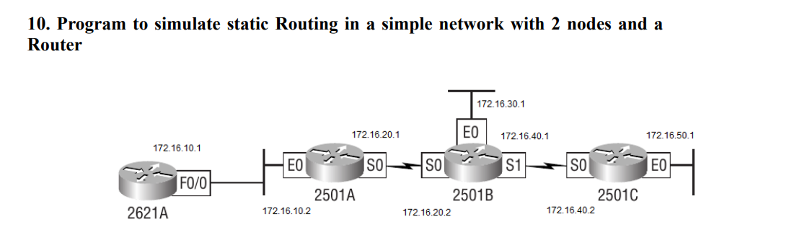

1. **2621A Configuration**

Router> en

Router#config t

Router (config)#hostname 2621A

2621A(Config)#interface fa0/0

2621A(Config-if)#ip address 172.16.10.1

255.255.255.0

2621A(Config-if)#no shut

To view the IP routing tables created on a Cisco router, use the privileged mode command show ip route.

2621A#sh ip route

1. **2501A Configuration**

Router#config t

Router(config)#hostname 2501A

2501A(config)#int e0

2501A(config-if)#ip address 172.16.10.2

255.255.255.0

2501A(config-if)#no shut

2501A(config-if)#int s0

2501A(config-if)#ip address 172.16.20.1

255.255.255.0

2501A(config-if)#no shut

2501A#sh ip route

1. **2501B Configuration**

Router#config t

Router(config)#hostname 2501B

2501B(config)#int e0

2501B(config-if)#ip address 172.16.30.1

255.255.255.0

2501B(config-if)#no shut

2501B Configuration..

2501B(config-if)#int s0

2501B(config-if)#ip address 172.16.20.2

255.255.255.0

2501B(config-if)#clock rate 64000

2501B(config-if)#no shut

2501B#sh ip route

1. **2501C Configuration**

Router(config)#hostname 2501C

2501C(config)#int e0

2501C(config-if)#ip address 172.16.50.1

255.255.255.0

2501C(config-if)#no shut

2501C(config-if)#int s0

2501C(config-if)#ip address 172.16.40.2

255.255.255.0

2501C(config-if)#no shut

2501C#sh ip route

---------------------------------------------------------------------

11. Program to simulate Static Routing in larger network

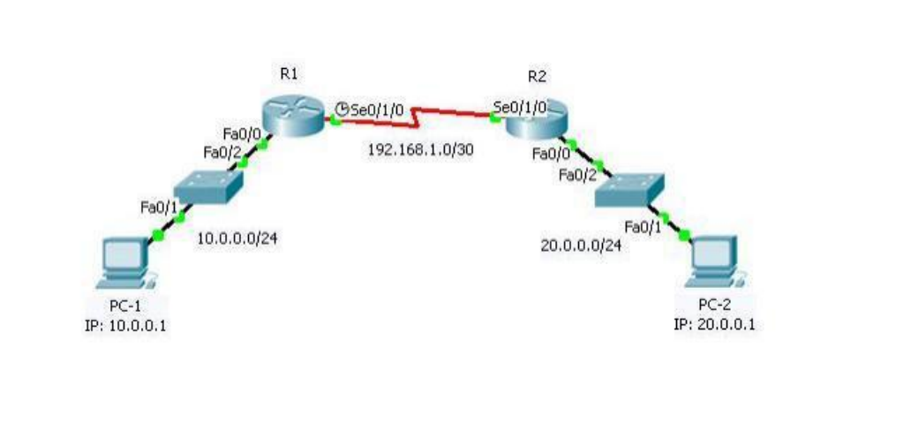

---------------------------------------------------------------------

https://www.geeksforgeeks.org/implementation-of-static-routing-in-cisco-2-router-connections/

https://mycomputernotes.com/configuration-of-static-routing-with-examples/

2 Router 2811

2 Switch 2950

2 Hosts

Host A -> connect to SwitchA fa0/1 Host B -> connect to SwitchB fa0/1

IP : 192.168.1.2 IP : 192.168.2.2

Mask : 255.255.255.0 Mask : 255.255.255.0

Default: 192.168.1.1 Default: 192.168.2.1

Connect each Switch fa0/2 to Router fa0/0

Connect RouterA S0/0/0 to RouterB S0/0/0 [RouterA would be DCE so we need to set clock rate]

A

Router>en

Router#config t

Router(config)#int fa0/0

Router(config-if)#ip addr 192.168.1.1 255.255.255.0

Router(config-if)#no shutdown

Router(config-if)#exit

Router(config)#int serial 0/0/0

Router(config-if)#clock rate 19200

Router(config-if)#ip addr 10.0.0.1 255.255.255.0

Router(config-if)#no shutdown

Router(config-if)#exit

Router(config)#ip route 192.168.2.0 255.255.255.0 20.0.0.1

Router(config)#ex

Router#write

Building configuration...

[OK]

Router#

B

Router>en

Router#config t

Router(config)#int fa0/0

Router(config-if)#ip addr 192.168.2.1 255.255.255.0

Router(config-if)#no shutdown

Router(config-if)#exit

Router(config)#int serial 0/0/0

Router(config-if)#ip addr 20.0.0.1 255.255.255.0

Router(config-if)#no shutdown

Router(config-if)#exit

Router(config)#ip route 192.168.1.0 255.255.255.0 10.0.0.1

Router(config)#exit

Router#write

Building configuration...

[OK]

Router#